Assignment 1: Ensure the script checks if a specific file (e.g., myfile.txt) exists in the current directory. If it exists, print "File exists", otherwise print "File not found".

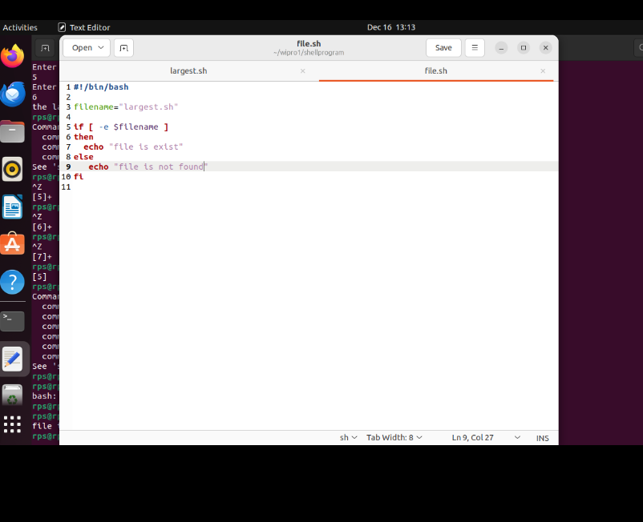

Output:

